

API Authentication

Version 1.0

Contents
1
API Authentication 1
1. Overview 2
2. What is M2M Authentication & When to Use? 3
3. Prerequisites: 3
4. Step-by-Step Integration Guide 3
4.2. How to Generate Access Token: 4
4.3. How Use the New Token to Call APIs: 6
4.4 Transition Timelines 7
4.5 Webhooks 7

1. Overview
Currently, customers can login using username and password, now we are implementing additional login options to customers. Under this the first one is machine-to-machine authentication (M2M) and second one OAuth mechanism.
In the current design, every public-facing API requires an access token. The token is provided in the Authorization header and is used to authenticate the user.

2. What is M2M Authentication & When to Use?
Machine-to-machine (M2M) authentication is how software, services, and devices securely prove their identity to each other—without a human/user involved—so they can exchange data or call APIs.
Note: This approach is recommended only when user interaction is not required, such as APIs.

3. Prerequisites:
- The firm/company should be using safesend product.
- The user must have access to the Developer section page.
4. Step-by-Step Integration Guide
4.1. How to obtain the client id and client secret:
- Navigate to the SafeSend website (http://www.safesendreturns.com), then choose the Developer section. (Please note: This will not be available in the application until April 25th.)
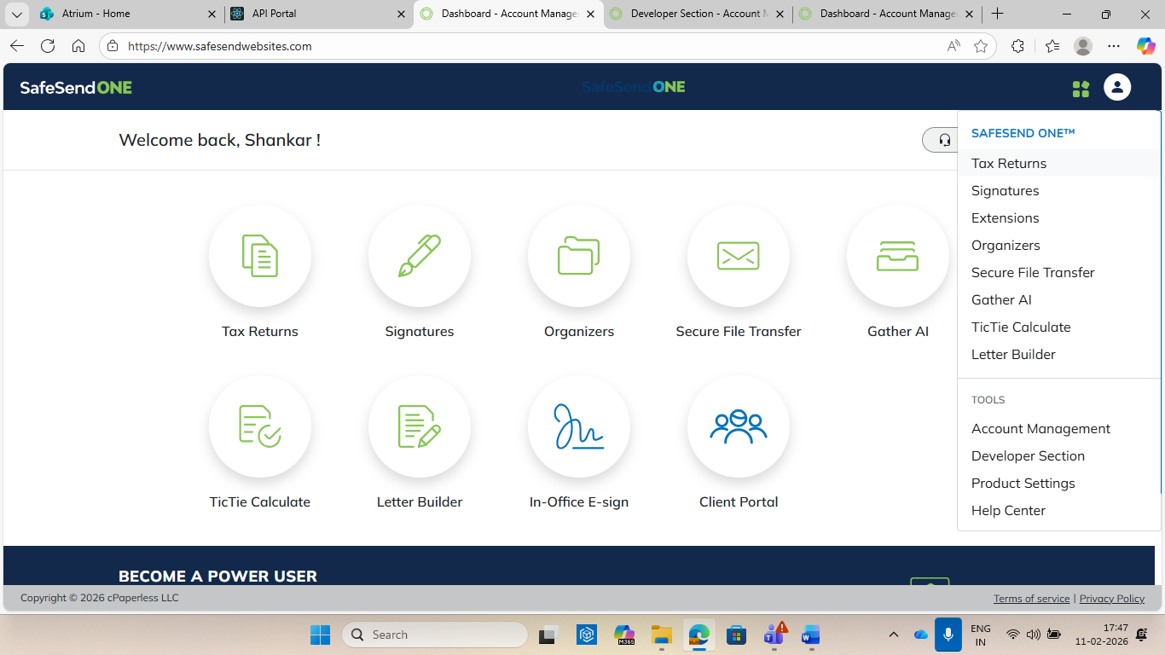
- From the Developer section page, you can obtain the Client ID, Client Secret, and Audience.
  - On the Developer section page, click the Regenerate button below the secret key to generate the client secret. The client secret is displayed only once. Copy it immediately; after you do, it will no longer be visible.
  - On the developer section is also the Client ID. This will always be visible and will remain static.
  - We will also show the “audience” variable which is needed as well. This will also be visible and static.
  - Please Note: All these variable are FIRM WIDE and are not for an individual user. This is a firm level authentication.
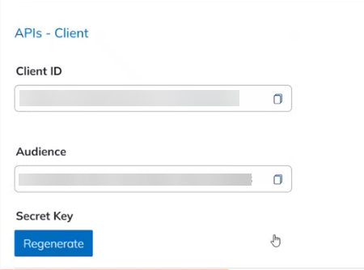

4.2. How to Generate Access Token:
- To obtain an access token for M2M login, use the API URL and request body as shown below.
  - API URL: https://auth-prod.thomsonreuters.com/oauth/token
  - Request body:
{
"client_id": "<YOUR_CLIENT_ID>",
"client_secret": "<YOUR_CLIENT_SECRET>",
"audience": "<TARGET_API_AUDIENCE>",
"grant_type": "client_credentials"
}

Request Body Description:
Property | Required | Type | Description
client_id | True | String | App identifier issued during app registration in developer section page. Obtained through SafeSend Developer Section.
client_secret | True | String | App secret used to authenticate the request. Keep this confidential. Obtained through SafeSend Developer Section.
Audience | True | String | The identifier of the target API. Obtained through SafeSend Developer Section.
Grant type | True | String | The authentication flow. Please pass “client_credentials” to generate a bearer token.

- The response token includes four properties: access_token, scope, expires_in, and token_type. A sample response is shown below.
Response Body:
{
"access_token": "<ACCESS_TOKEN>",
"scope": "https://api.tr.com/auth/safesend.all",
"expires_in": <TIME_IN_SECONDS>,
"token_type": "Bearer"
}

Response Body Description:
Property | Type | Description
Access_token | String | Authentication Token to pass for all further API calls.
scope | String | Refresh token to refresh the current session.
expires_in | Integer | Expires On period for the generated authentication token. It is in seconds.
token_type | String | Type of the generated authentication token.

- Common API Endpoint Error Codes and Their Descriptions: Below are common error codes that you may see and the reason why you are seeing them.
- 200: The request has succeeded.
- 401-Unauthorized: Access denied due to missing or invalid credentials. Verify the client_id, client_secret, and that the access token is included in the Authorization header.
- 403-Forbidden: Credentials are valid, but the client is not allowed to access the resource. Check the audience and grant_type, and confirm the client has permission for the target API.
Note: When an access token expires, re-generate a new one.

4.3. How Use the New Token to Call APIs:
To call an API such as "SSR Returns – Post Upload," include the access token and the user's email in the request.
Please note that all SafeSend API endpoints will require the “x-email” header going forward. We will not update the versioning to only include this new header so all existing APIs will require this new header after the final transition.
Example: Replace placeholders with real values.
POST "https://api.safesend.com/ssr/v2/return/upload" \
--header "Authorization: Bearer <ACCESS_TOKEN>" \
--header "Content-Type: application/json" \
--header "x-email: <X_EMAIL>" \
--data '{
"documents": [
"string"
],
"fileURLs": [
"string"
],
"correlationId": "string",
"rid": "string",
"clientId": "string",
"delayRecognition": bool,
"taxSoftware": int,
"callbackUri": "string"
}'

X-Email must be passed in the header - Pass X-Email in the request header, using the email of a SafeSend user who has the API Developer permission and who is making the call. If the user is in any of the three categories below, you must include their email. The call will fail if an valid email is not passed in the header.
- Users with Suite - API Developer Role
- Users with System Admin Role
- Users in Admin user group
Common Error Codes and Their Descriptions
- 200 – Request succeeded.
- 400 - BadRequest – X-Email header missing, X-Email value invalid, or user not found.
- 401 - Unauthorized -Authorization header missing, token invalid, or token expired
- 403 - Forbidden – Authentication succeeded, but the user is not permitted to call this API.

4.4 Transition Timelines
We will continue to support the old authentication method (SafeSend email and password to existing Login API) until July 25th (need to confirm). During this transition period you can still pass the SafeSend generated bearer token and your subscription key into the “x-api-key” header as normal. You can also use the new CIAM bearer token and “x-email” header as well.
After the July release we will no longer support the SafeSend bearer token and “x-api-key” header and all API calls must use the new headers as outlined in this document.

4.5 Webhooks
Webhooks will be unaffected by this change and nothing needs to be done for their continued function.

